**Acoustic model**

**Language model**

**Feature Extraction**

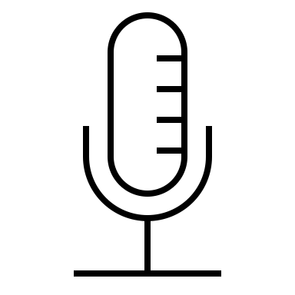

**Decoder**

INPUT

**Lexicon**

Recognized text output

**Final Text**

**Text Processing using NLTK**

* **Word Tokenizer**
* **POS Tagging**
* **Remove stop words**
* **Lemmatization**



OUTPUT